### RICH PICTURE (AS-IS)

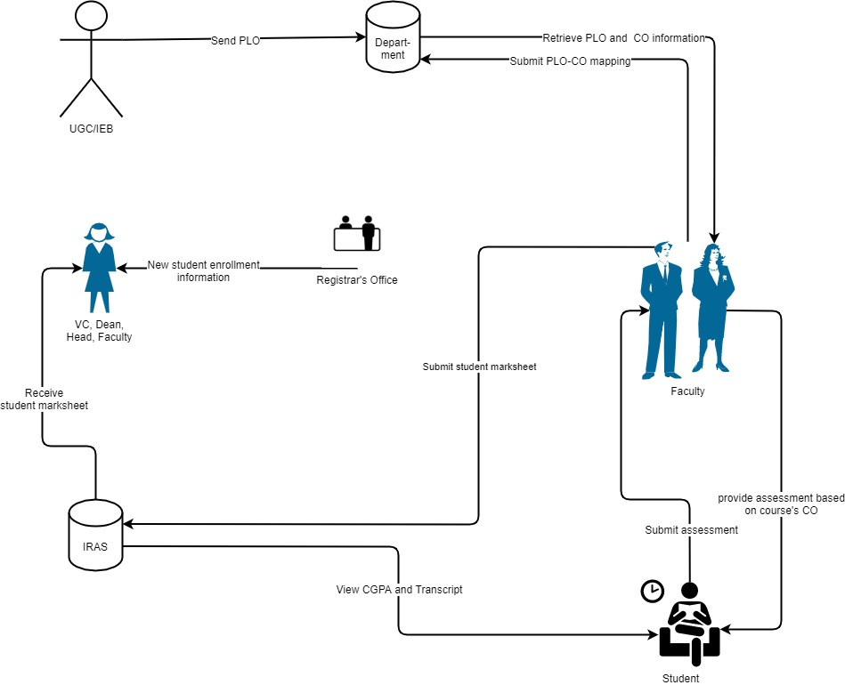

Figure : Rich Picture As-Is

### SIX ELEMENTS (AS-IS)

|  |  |  |  |  |  |  |
| --- | --- | --- | --- | --- | --- | --- |
| Process | System Roles | | | | | |
| Human | Non-Comp  Hardware | Computing Hardware | Software | Database | Network &  Communication |
| RECEIVE NEW STUDENT ENROLLMENT INFORMATION | **Registrar office:**  1)log in to computer  2) Receive request for enrolment information from VC, head of department, faculty, and dean.  3) Retrieve enrollment information from registrar office’s DB  4) Provide requested enrolment information to faculty, dean, head of department, VC as soft copy or printed copy.  **Faculty, dean, head of department, VC:**  1) log in to computer  2) Sends request for student enrollment information to registrar’s office.  3) Receive enrollment student information from registrar’s office. | **Paper and Stationary:**  Send student enrollment information as printed copy to VC, head of department, faculty, and dean.  **Folders**  Store student enrolment information as printed copies. | **Computer:**  1) Used by registrar office employees to send and/or receive new enrolment information to VC, head of department, faculty, and dean.  2) Used by VC, head of department, faculty, and dean to request and receive new student enrollment information.  **Registrar’s Office DB server :**  Used registrar’s office store student enrollment information  **Printer:**  To print new student enrollment information.  **Networking Device:**  Used for internet access, internal database access or communicational use. | **Operating System:**  Used in Registrar’s office, VC, head of department, faculty and dean’s computer.  **Email client:**  Used by Registrar’s office, VC, head of department, faculty and dean to send and receive new student information.  **Office suite:**  Used by VC, head of department, faculty and dean to generate enrollment trend. | **RDBMS:**  Used by Registrar’s office database to store new student enrollment information.  **Excel Files:**  Used to store new student enrollment information in local computer. | **Internet:**  Used to send or receive student enrollment information between Registrar’s office and VC, head of department, faculty, dean  **Telephone:**  Used for verbal communication between Registrar’s office and VC, head of department, faculty and dean. |
| Receive student mark-sheet | **VC, head of department, faculty, dean :**  1) Log in to their corresponding IRAS account.  2) Search for course wise, semester wise department wise student mark-sheet.  3) Download the mark-sheet. | **Paper and Stationary:**  Used to print the downloaded mark-sheet.  **Folder :**  Store the printed mark-sheet. | **Computer:**  Used by VC, head of department, faculty, and dean to retrieve and download student mark-sheet from their IRAS account.  **printer:**  Used by VC, head of department, faculty, and dean to print downloaded mark-sheet.  **IRAS DB server:**  Used by IRAS to store student mark-sheet.  **Networking device:**  Used for internet access, internal database access | **Operating system:**  Used in VC, head of department, faculty and dean’s computer.  **IRAS:**  To retrieve mark-sheet.  **Office suite:**  Used by VC, head of department, faculty and dean to generate student performance trend. | **RDBMS:**  Used by IRAS to store student mark sheet.  **Excel Files:**  Used to store student mark-sheet local computer. | **Internet:**  Used by VC, head of department, faculty, dean to retrieve student mark sheet from their corresponding IRAS account. |
| View CGPA and Transcript | **Student:**  1) Students have to login to their IRAS account at first  2) They can view their CGPA from their IRAS dashboard  3)In order to view their transcript, they have enter year and semester from their dashboard and click on “Transcript” button to download the transcript of that particular semester | **Paper:**  May be used by students to print their transcript  **Folder:**  To store the printed transcript | **Computer:**  Used by students to visit the IRAS website and view CGPA and transcript  **Printer:**  Used by students to print the transcripts  **IRAS DB server:**  Used by IRAS to store student CGPA and transcripts  **Networking device:**  Used for internet access, internal database access | **Operating system:**  Used in students’ computer.  **IRAS:**  To retrieve student CGPA and mark-sheet.  **PDF Viewer:**  Used to students view the downloaded transcripts | **RDBMS:**  Used by IRAS to store student CGPA and transcripts | **Internet:**  Used by students to login to their IRAS account and access their CGPA and transcripts. |
| Record student assessments and submit mark-sheet | **Faculty:**  1)Take classes, record student attendance and student class participation  2) Request department for PLO and CO information of a particular course  3) Receive and download PLO and CO from department  4) Set assignment and exam paper based the CO.  5) Organize schedule and room for exam and notify students.  6) Collect exam paper and assignment from students.  7) Checks the assignment and exam paper and records marks on mark-sheet  8) Log in to IRAS and Submits mark-sheet to IRAS.  **Department:**  1) Receive request for PLO and CO for a particular course from faculties  2) Send PLO and CO to faculties  **Student:**  1) Attend classes and participates in class discussion  2) Receives assignment and exam notifications from faculties  3) Attempts assignment problems and submits them to faculties  4) Takes exam on designated schedule and classroom and submits exam paper to faculties | **Pen and paper:**  1) Used by department to send PLO and CO as printed form to faculty.  2) Used by teacher to make exam paper and assignment.  3) Used by student to take exam and assignment.  **Folder:**  Used by department student and faculty to store paper. | **Computer:**  1) Used by faculty to create assignment and exam paper.  2) Used by department to store PLO and CO information.  3) Used by student to view exam paper or assignment.  **IRAS DB server:**  Used by faculty to store student mark sheets.  **Printer:**  1) Used by department to print PLO and CO information.  2) used by faculty to print assignment and exam paper  **Networking device:**  Used for internet access, internal database access | **Operating system:**  Used in faculty, department and student’s computer.  **Office suite:**  Used by faculty to create assignment and exam paper. | **RDBMS:**  Used by faculty to store student mark sheets in IRAS DB. | **Internet:**  1) Used by faculty and department to receive and send PLO and CO information.  2) Used by student, faculty and department to communicate.  **Telephone:**  Used for verbal communication between faculty and student. |
| PLO CO mapping | **Faculty:**  1) Request department for PLO and CO information.  2)receive PLO and CO information from department  3) Download the PLO co information.  4) Discuss with other faculty member to create PLO and CO map.  5)sends PLO CO map to department  **Department:**  1) Receive request from faculty for PLO and CO information.  2) Send PLO and CO information to faculty.  3) Receive PLO and CO mapping from faculty.  4) Store PLO co map.  5) Download the PLO co map. | **Pen and paper:**  Used by faculty to view PLO and CO information as printed form. | **Computer:**  Used by faculty and department to receive and send PLO and CO information.  **Printer:**  Used by faculty to print the PLO and co information. | **Operating system:**  Used in department and faculty’s computer.  **pdf viewer:**  To see the PLO and co information. |  | **Internet:**  Used by faculty and department to receive and send PLO and CO information and communicate with each other.  **Telephone:**  Used for verbal communication between faculty and department. |